**Datatypes and Format Specifiers Assignment**

**1. WAP to read the following information at run time and to display. Choose appropriate data type and format specifier.**

**1. username [maximum of length 125]**

**2. age**

**3. Salary [float]**

**4. Designation code [as short type with values {1, 2, 3, 4, 5, 6}**

**5. Gender [a single char field]**

**b**

**2. WAP to read a user choice as ‘y’ or ‘Y’ or ‘n’ or ‘N’ and display read choice as “Yes” or “No”**

**according to the input received.**

**‘y’ or ‘Y’à display “Yes”**

**‘n’ or ‘N’à display “No”**

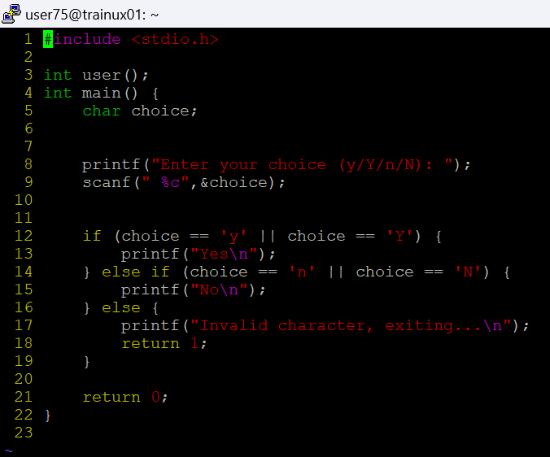

**for any other character received à display “invalid character” and exit**

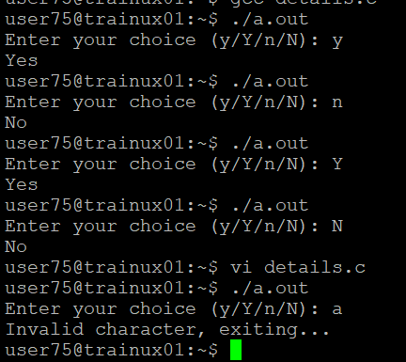

**3. WAP to read a number in decimal (0-127) and display it in 2 digit hex characer.**

